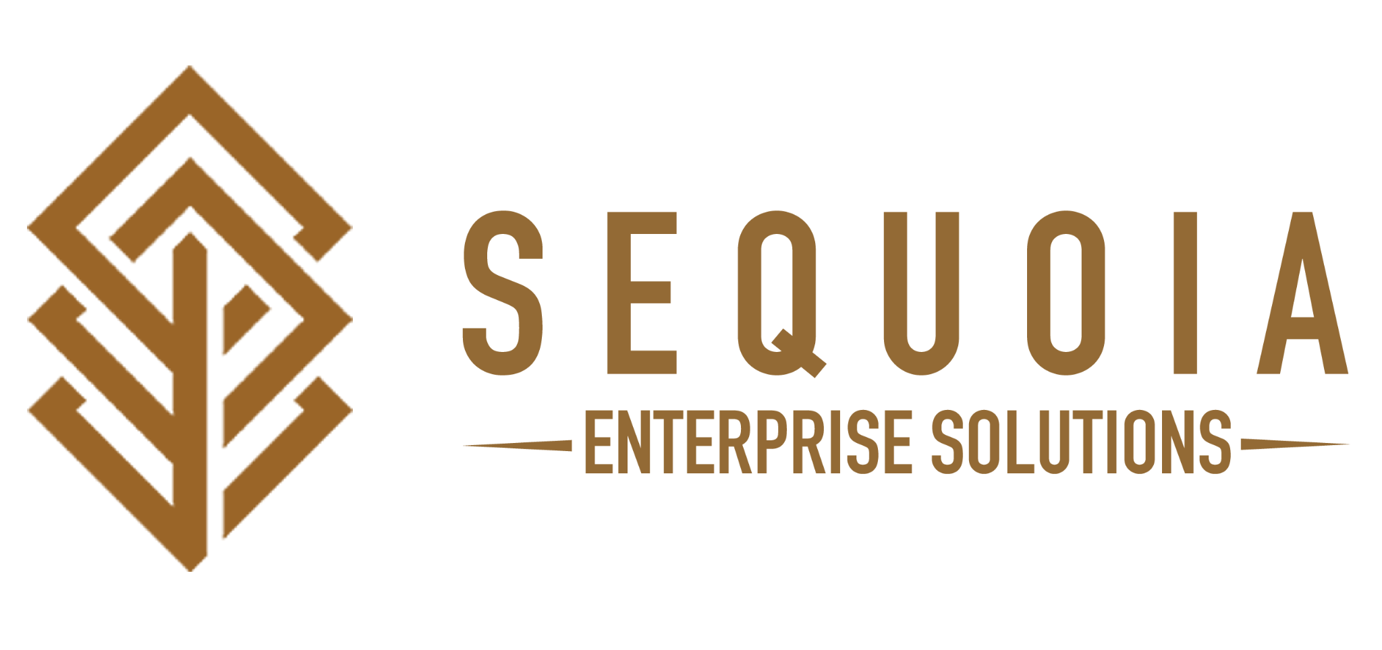

The Wellness Program (EHMP)
Elevator Pitch

We have a program that offers all the following:
- No net cost to your company
- We don't replace your health insurance or your broker.

If you implement this program,
- It will bring net positive revenue for your company
- With net neutral cost for your employees (no effect to their take-home pay).

When it comes to benefits, has anyone ever proposed net positive revenue and net neutral cost for you and the employees? Let me know when we can set a time to show the program to you.

